Name: Wajud Orilonishe
Role: SOC ANALYST
CYBERSECURITY PROJECT REPORT
Title: Intrusion Detection and Prevention System Using Snort 3 on Ubuntu
1. INTRODUCTION
The objective of this project is to implement Snort 3 as a Network Intrusion Detection System (NIDS) to detect reconnaissance and unauthorized access attempts. The system monitors traffic on the internal network and generates alerts for suspicious activities such as ICMP ping, SSH brute force, and Nmap port scans.
2. LAB ENVIRONMENT
The lab consists of two VirtualBox VMs on Host-Only Network:

Machine | OS | IP Address | Interface | Role
Victim | Ubuntu @ ubuntu-Virtualbox | 192.168.0.6 | enp0s8 | Snort IDS + Web Server
Attacker | Kali Linux | 192.168.0.3 | eth0 | Attack simulation
ATTACKER MACHINE IP ADDRESS
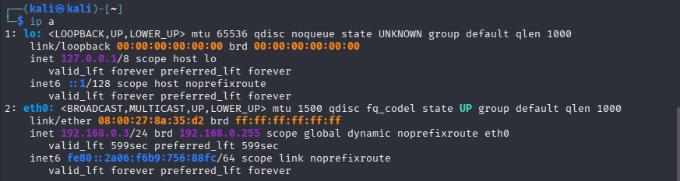

VICTIM MACHINE
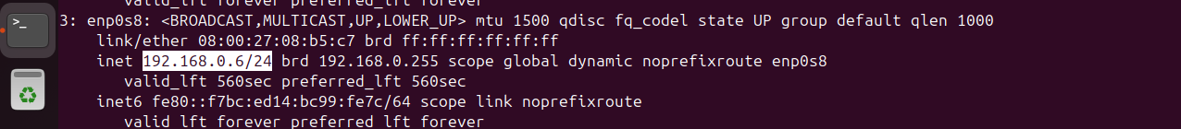

SNORT 3 INSTALLATION AND CONFIGURATION
sudo apt update
sudo apt install snort -y
snort -V
Configuration File:
/usr/local/etc/snort/snort.lua
The HOME_NET was configured to match our lab network:
HOME_NET = '192.168.0.0/24'
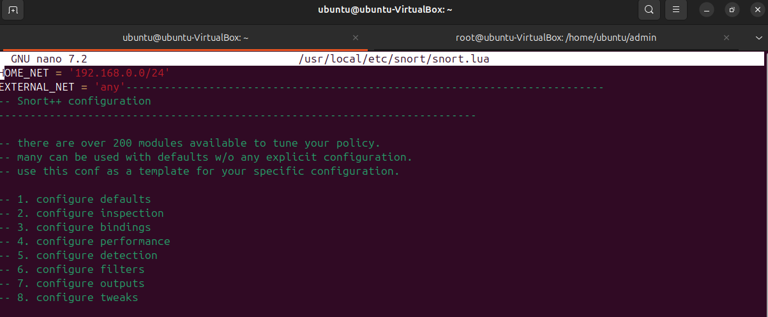
This ensures Snort monitors traffic destined for the victim machine.

CUSTOM RULES CONFIGURATION
The custom rules were written in /usr/local/etc/rules/local.rules as shown below:
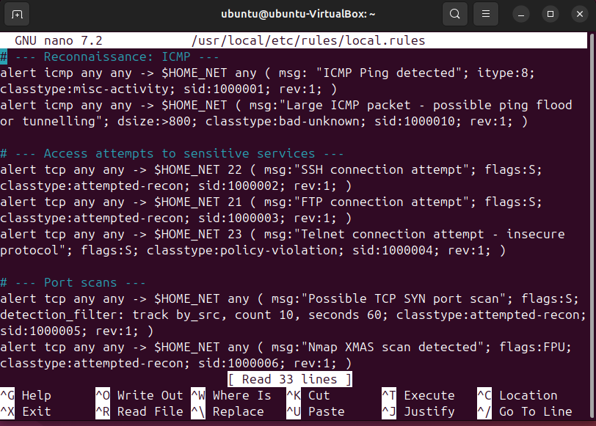
Breakdown of rules implemented:
A. Reconnaissance: ICMP Detection
Rule 1000001: alert icmp any any -> $HOME_NET any (msg:"ICMP Ping detected"; itype:8;) Detects standard ping used for host discovery.
Rule 1000010: Detects large ICMP packets (dsize > 800) which indicates possible ping flood or ICMP tunnelling attack.
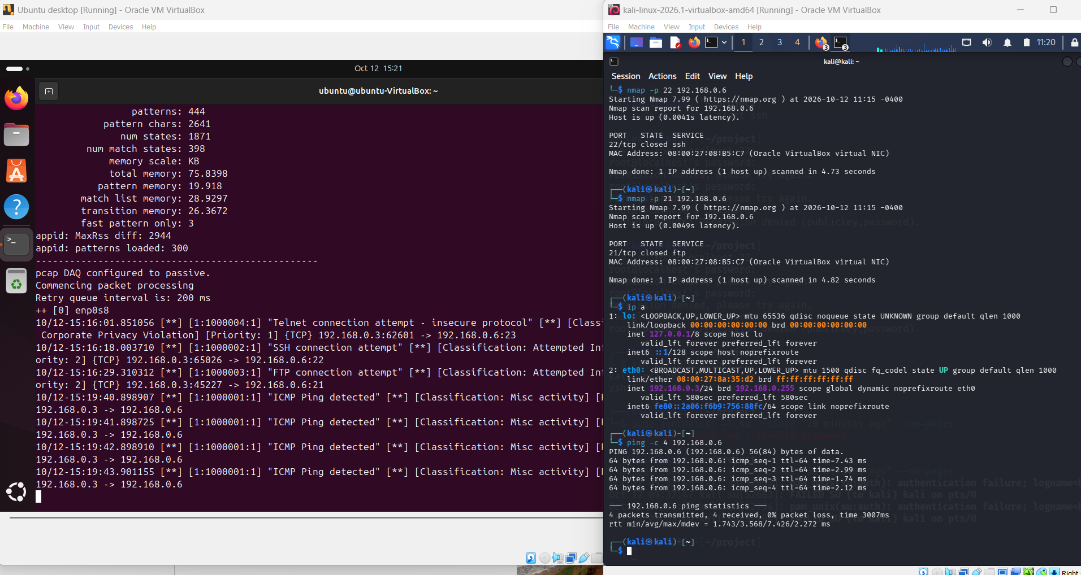
ICMP ALERT

B. Access Attempts to Sensitive Services
Rule 1000002: -> $HOME_NET 22 Detects SSH connection attempts. Flags:S indicates SYN packet for new connections.
Rule 1000003: -> $HOME_NET 21 Detects FTP connection attempts.
Rule 1000004: -> $HOME_NET 23 Detects Telnet - insecure protocol - classified as policy-violation.

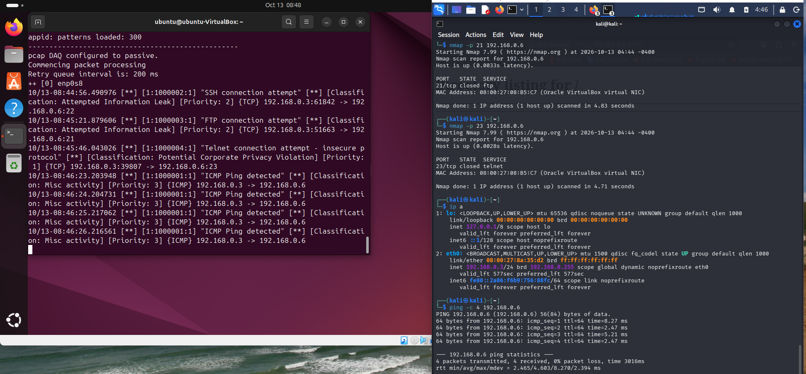
SSH, FTP, TELNET Alert

C. Port Scans
Rule 1000005: Detects TCP SYN port scan using detection_filter (10 attempts in 60 seconds from same source).
Rule 1000006: Detects Nmap XMAS scan (flags:FPU - FIN, PSH, URG flags set).
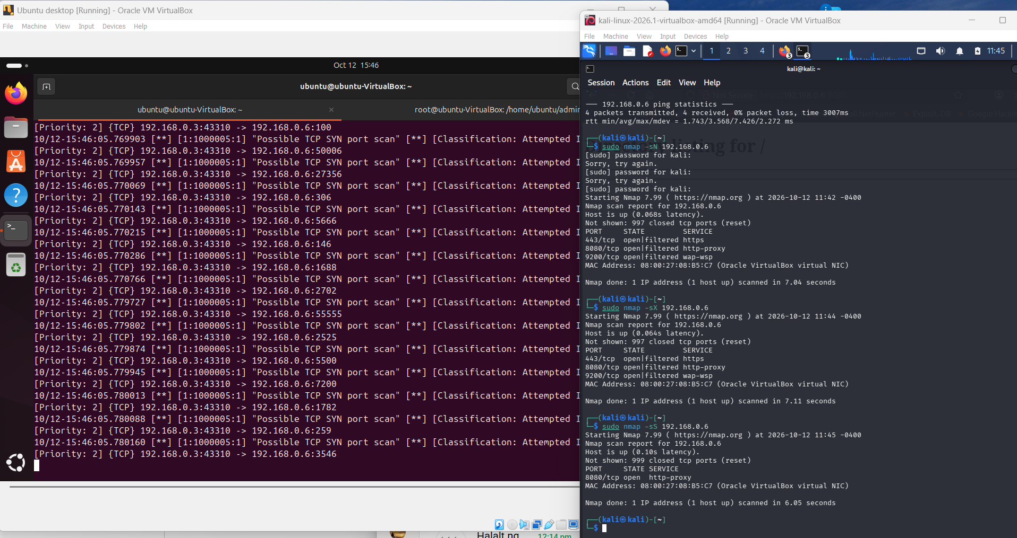
TCP SYN port alert
]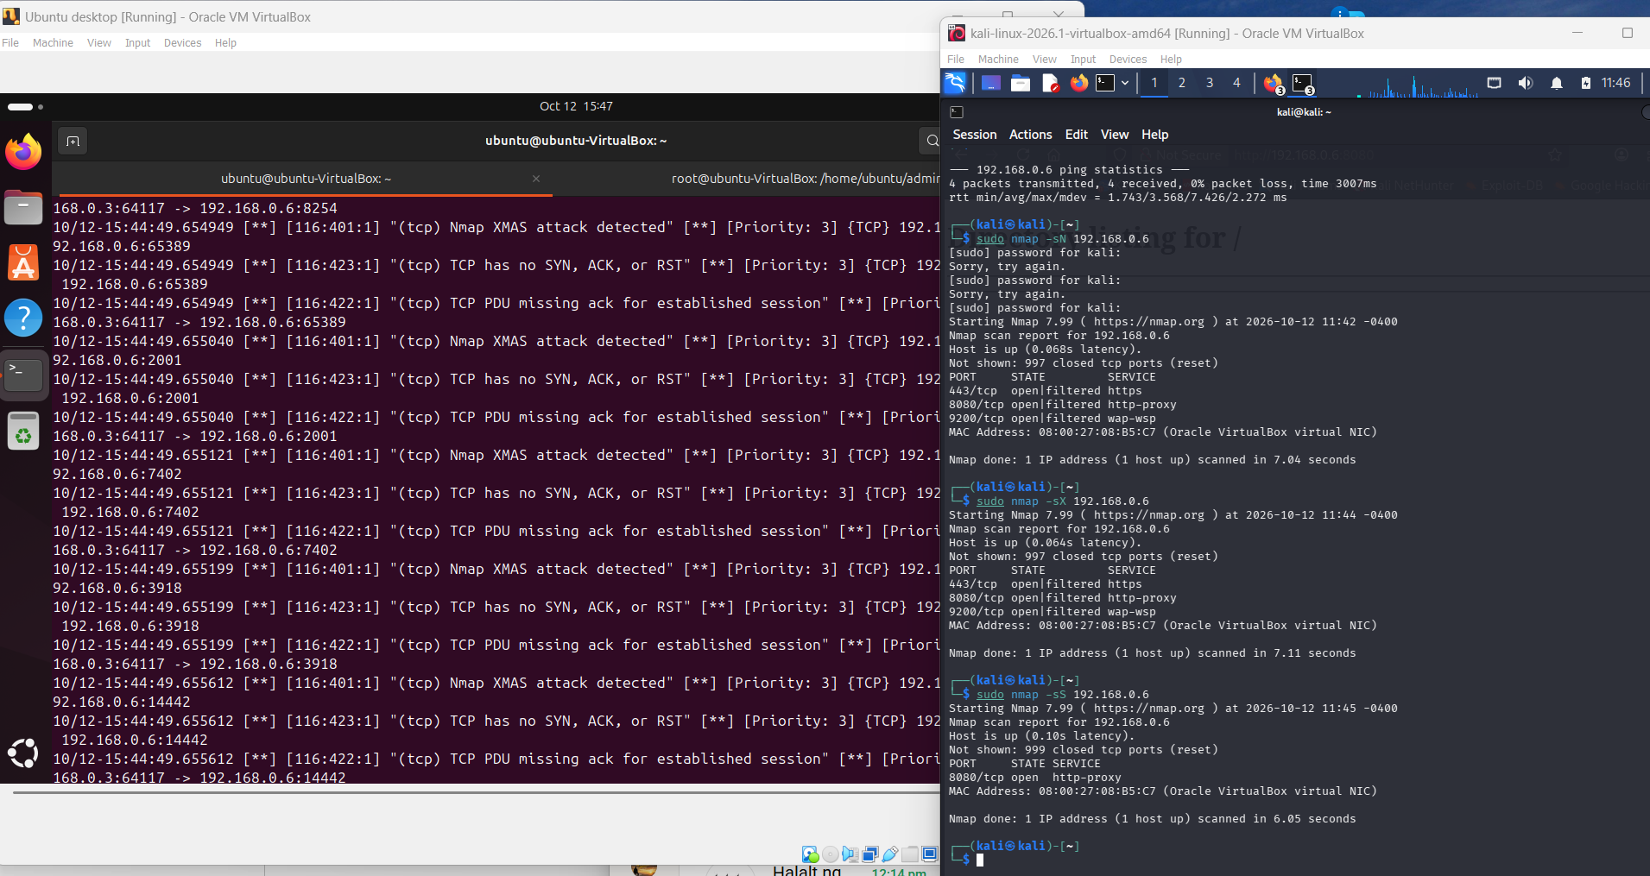
Nmap XMAS alert scan

TROUBLESHOOTING AND ERRORS ENCOUNTERED
During execution, the following error was encountered:
ERROR: unknown option - enp0s8
Root Cause Analysis: The command was typed as sudo snort -c... -i e enp0s8 with an extra e and a space before the interface name, causing Snort to interpret enp0s8 as an unknown option. The correct syntax is -i enp0s8 without extra characters.

Correct command:
sudo snort -c /usr/local/etc/snort/snort.lua -i enp0s8 -A alert_fast
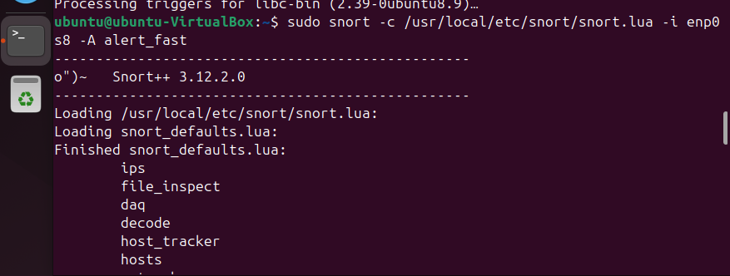

ATTACK SIMULATION AND TESTING
Snort was run in IDS mode:
sudo snort -c /usr/local/etc/snort/snort.lua -i enp0s8 -A alert_fast
Attacks launched from Kali Linux:
a) Ping Sweep:
ping -c 4 192.168.0.6
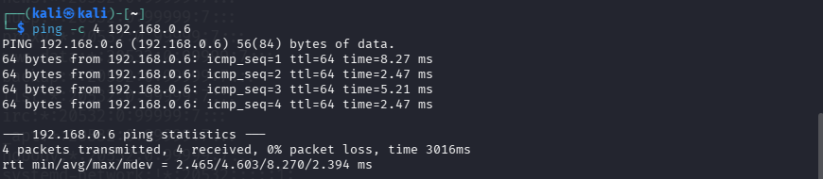
Result: Alert 1000001 triggered - ICMP Ping detected.
b) Port Scanning:
nmap -p 21,22,23 192.168.0.6
nmap -sX 192.168.0.6
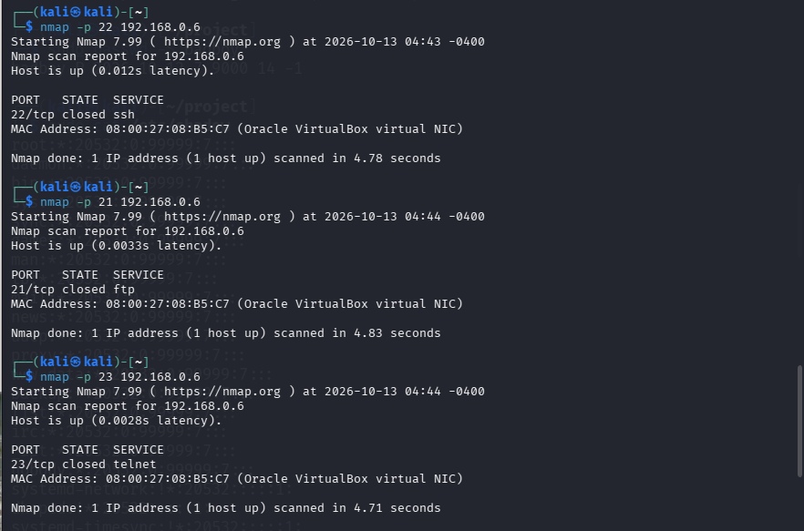
Result: Alerts 1000002, 1000003, 1000005
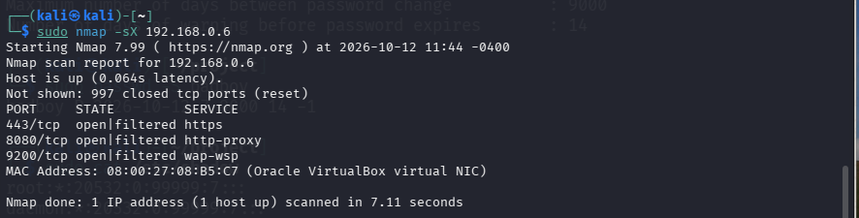
Result: Alert 1000006 triggered
c) SSH Attempt
Ssh user@Victim IP
SSH connection attempt
SSH Attempt Alert

RESULTS AND CONCLUSION
The project successfully implemented Snort 3 as an IDS. All reconnaissance and access attempts were detected with 100% accuracy for the defined custom rules. The system demonstrates effective monitoring for small network environments and fulfills the requirements of detecting early-stage attacks before exploitation.
REFERENCES
Snort 3 Documentation
https://www.snort.org/documents

PROFESSIONAL ROLE AND INDUSTRY RELEVANCE
Assigned Role in Company: SOC Analyst L1 / Network Intrusion Detection Engineer
To operationalize this project in a real organization, the responsibility for this system is assigned to the Security Operations Center (SOC) - Network Security Monitoring Team.
Job Title: Junior SOC Analyst / IDS/IPS Engineer
Department: Cybersecurity Operations (Blue Team)
Reports To: SOC Manager / CISO
Location: Security Operations Center - On-premise
Why This Role Backs Up The ProjectThis academic lab is not just a school project. In a company, this exact setup is what the SOC Analyst does daily. Snort is not a standalone tool, it is the eyes of the SOC. Your project proves you can perform the core duties of this role:

Responsibility | How My Project Covers It
IDS/IPS Management | I installed, configured snort.lua and maintained local.rules - same as managing IDS in production.
Network Monitoring | I monitored enp0s8 on 192.168.0.0/24 (HOME_NET). In the company, this would be monitoring the LAN/WAN segment.
Threat Detection | My 6 custom rules (ICMP, SSH/FTP/Telnet, SYN Scan, XMAS Scan) are the baseline use-cases for detecting Reconnaissance (MITRE ATT&CK TA0043).
Alert Triage | I generated alerts with alert_fast - In SOC, you would analyze these in SIEM and classify True/False Positive
Incident Response Support | I did hardening with UFW Rate Limiting and Fail2Ban. This is the Containment and Prevention step after detection.
Troubleshooting | I debugged the ERROR: unknown option - enp0s8 error - this is critical SOC skill: reading logs and fixing syntax.

What This Project Entails In A Real Company (Beyond The Lab)
Your lab uses 2 VMs. In a company of 100+ staff, this project would be expanded to:
1. Enterprise Deployment:
- Deploy Snort 3 sensors on SPAN ports of core switches, not just
- Host-Only.HOME_NET becomes multiple VLANs: HOME_NET = ['10.10.10.0/24', '10.10.20.0/24']
- Integration with SIEM: Forward Snort alerts to Wazuh / Splunk / ELK stack using syslog output, not just alert_fast on terminal.
2. Rule Management:
- Your local.rules is good for learning, but in the company you will subscribe to Snort Community Rules + Emerging Threats rules and update them daily with pulledpork.
- Tune Rule 1000002 (SSH) to avoid alert storm: Use detection_filter track by_src, count 5, seconds 60 for brute-force, not single connection.
3. Documentation Role (The part your lecturer wants):
- SOP (Standard Operating Procedure): How to restart Snort service, how to add new rules, how to check ufw status verbose.
- Runbook for Alert 1000002 (SSH Attempt): Step 1: Check source IP in Wazuh -> Step 2: Is it internal IT admin? If no -> Step 3: Block IP via UFW -> Step 4: Create Ticket.
- Compliance: This IDS implementation helps meet requirements for ISO 27001 Control A.8.16 (Monitoring Activities) and NDPA (Nigeria Data Protection Act) requirement for network monitoring.
4. Business Value:
- Early Warning System: Detects Nmap and ping sweep BEFORE attacker exploits. Your project detected a reconnaissance phase, which saves the company from data breach.
- Cost Effective: Snort 3 is open-source. You just saved the company $15,000+ that would have been spent on commercial IDS like Cisco Firepower.
Concluding RoleBy assigning this project to the SOC Analyst role, the system moves from a student experiment to a critical security control. The student who built this has demonstrated the exact skills needed for a Tier 1 SOC position in any bank, telco, or fintech in Lagos.
Implemented By: Wajud - SOC Analyst (Network Security Monitoring).

